Spectral coherence: USDCHF and EURGBP
Method 21 / daily log returns / Welch magnitude-squared coherence / Alpari D1 full available history

Study setup
Logical pair: USDCHF , EURGBP
Broker symbols: USDCHF_i , EURGBP_i
Snapshot: 2026-11-03_majors_alpari_D1
Timeframe: D1
Matched return window: 1999-01-06 to 2026-11-02 (UTC bar dates)
Matched return count n: 7182
Dropped unfinished last bar dated 2026-11-03 UTC after a tick-volume check against the prior complete day.
Welch: fs=1.0, nperseg=256, noverlap=128, window=hann, detrend=constant
Headline: gamma^2 nearest f=1/5; also 1/21 and 1/63
Complete matched rows (Excel): USDCHF-EURGBP_Spectral_D1.xlsx
Complete matched rows (HTML table): USDCHF-EURGBP_Spectral_D1_data.html

Method carried forward
Magnitude-squared spectral coherence gamma^2(f) measures shared linear power between matched daily log returns of close, ln(close_t / close_t-1), at each frequency f (cycles per day). Quotes are not inverted. Welch settings are frozen: fs=1, nperseg=256, noverlap=128, window=hann, detrend=constant. Headline is gamma^2 at the frequency bin nearest f=1/5 (five-day cycle from the formula sheet). Also reported: gamma^2 nearest f=1/21 and f=1/63, mean gamma^2 over the frequency grid, and phase of the cross-spectrum at the 1/5 bin. Coherence is unsigned (0 to 1); phase carries timing. Same-sample Pearson r is a side check only. This is not causation and not a trading signal.

Results (headline)
gamma^2 near 1/5: 0.069904
bin f (1/5): 0.199219
phase at 1/5 (rad): 2.450367
gamma^2 near 1/21: 0.189118
gamma^2 near 1/63: 0.138420
mean gamma^2: 0.124637
Pearson r: -0.325886

Target-frequency summary
period | target_f | f_bin | gamma2 | phase_rad
5 | 0.2 | 0.19921875 | 0.06990355 | 2.4503668
21 | 0.04761905 | 0.046875 | 0.18911765 | -2.7807361
63 | 0.01587302 | 0.015625 | 0.13842023 | -2.5747626

Conclusion
Headline gamma^2 near f=1/5 for USDCHF and EURGBP: 0.0699 (bin f=0.199219, phase=2.4504 rad). At ~1/21: 0.1891; at ~1/63: 0.1384. Mean gamma^2 = 0.1246. Pearson r = -0.3259. This is frequency-domain linkage, not a trading signal.

Charts
Daily closes

Daily log returns

Spectral coherence gamma^2(f)
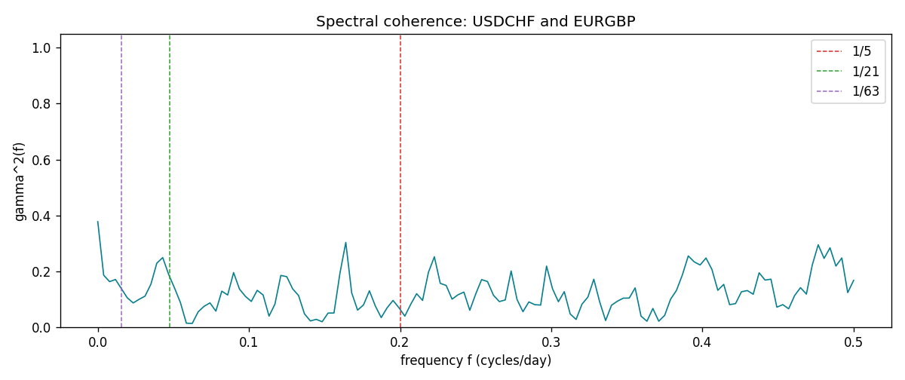

Data report
Matched rows and the coherence sheet are in the sibling Excel workbook named USDCHF-EURGBP_Spectral_D1.xlsx. Embedding all rows as a Word table is impractical; this file holds column summaries and the first and last 15 matched rows.
Columns: time, USDCHF_open, EURGBP_open, USDCHF_high, EURGBP_high, USDCHF_low, EURGBP_low, USDCHF_close, EURGBP_close, USDCHF_tick_volume, EURGBP_tick_volume, USDCHF_spread, EURGBP_spread, USDCHF_real_volume, EURGBP_real_volume, USDCHF_log_return, EURGBP_log_return
Column summaries (matched calculation rows)
column | count | mean | std | min | 25% | 50% | 75% | max
USDCHF_open | 7182 | 1.0972493 | 0.25210985 | 0.72022 | 0.9204925 | 0.989875 | 1.237175 | 1.8219
EURGBP_open | 7182 | 0.7869939 | 0.09664695 | 0.5734 | 0.6877 | 0.833905 | 0.865225 | 0.9769
USDCHF_high | 7182 | 1.1025378 | 0.25385182 | 0.73305 | 0.924695 | 0.99351 | 1.242175 | 1.8313
EURGBP_high | 7182 | 0.79007306 | 0.09702085 | 0.5789 | 0.6897 | 0.836955 | 0.8681 | 0.9799
USDCHF_low | 7182 | 1.092133 | 0.25052689 | 0.08565 | 0.9171825 | 0.986205 | 1.2312 | 1.8121
EURGBP_low | 7182 | 0.7842938 | 0.09646529 | 0.5682 | 0.685725 | 0.83166 | 0.86287 | 0.9661
USDCHF_close | 7182 | 1.09724 | 0.25200902 | 0.72025 | 0.9207375 | 0.98991 | 1.23715 | 1.8217
EURGBP_close | 7182 | 0.78703952 | 0.09664503 | 0.5735 | 0.687825 | 0.83398 | 0.865375 | 0.977
USDCHF_tick_volume | 7182 | 74362.695 | 113509.88 | 18 | 12814.25 | 40258.5 | 70446 | 858589
EURGBP_tick_volume | 7182 | 87145.49 | 145506.26 | 154 | 6593.75 | 44371 | 81432 | 1424684
USDCHF_spread | 7182 | 26.020746 | 24.692144 | 0 | 5 | 16 | 50 | 100
EURGBP_spread | 7182 | 21.320663 | 19.117614 | 0 | 4 | 13 | 40 | 50
USDCHF_real_volume | 7182 | 2.3303821e+10 | 8.915094e+10 | 0 | 0 | 0 | 0 | 1.9331921e+12
EURGBP_real_volume | 7182 | 2.7876168e+10 | 1.3522356e+11 | 0 | 0 | 0 | 0 | 3.5726265e+12
USDCHF_log_return | 7182 | -7.199e-05 | 0.00659004 | -0.19545699 | -0.00335239 | 7.626e-05 | 0.00331734 | 0.09051364
EURGBP_log_return | 7182 | 2.529e-05 | 0.00487429 | -0.03067367 | -0.00262165 | -0.00010006 | 0.00256425 | 0.06075387
First 15 matched rows (selected columns)
time | USDCHF_log_return | EURGBP_log_return
1999-01-06 | 0.013605652 | -0.013303338
1999-01-07 | -0.0093883841 | 0.011051402
1999-01-08 | 0.011040268 | -0.004943862
1999-01-11 | 0.0052963193 | -0.0012752393
1999-01-12 | -0.0098275602 | 0.0033970309
1999-01-13 | -0.018259701 | 0.00042381861
1999-01-14 | -0.0024256692 | -0.0019793588
1999-01-15 | 0.01794228 | -0.0076715819
1999-01-18 | -0.0031856384 | 0.00071280921
1999-01-19 | -7.2518946e-05 | -0.0014261269
1999-01-20 | 0.0072259871 | 0.0019960086
1999-01-21 | -0.0038232689 | -0.00071240297
1999-01-22 | -0.0001445609 | -0.0017118406
1999-01-25 | 0.0024546976 | -0.0054402425
1999-01-26 | 0.0020889617 | -0.00057438255
Last 15 matched rows (selected columns)
time | USDCHF_log_return | EURGBP_log_return
2026-10-13 | -0.0024955621 | 0.00020130374
2026-10-14 | 0.0029388325 | 0.0011241873
2026-10-15 | -0.0097855323 | -0.00087557391
2026-10-16 | -0.0036230826 | -0.0020380844
2026-10-19 | 0.0036351779 | -0.00056950988
2026-10-20 | -0.0026281224 | -0.0035906254
2026-10-21 | -0.00040027413 | -0.00140647
2026-10-22 | -0.0048036381 | -0.0018743924
2026-10-23 | 0.005652514 | 0.00082421033
2026-10-26 | 0.0018407959 | 0.00013133309
2026-10-27 | 0.0026100526 | -0.0019957343
2026-10-28 | -0.0010142111 | 0.00066967224
2026-10-29 | -0.0048680164 | -0.0011722209
2026-10-30 | 0.00071594559 | -0.0024205543
2026-11-02 | -0.0071459744 | 0.00089940465
First 15 frequency bins
f | gamma2 | phase_rad | period_days
0 | 0.37791092 | 3.1415927 | inf
0.00390625 | 0.18639482 | -3.0678032 | 256
0.0078125 | 0.16323884 | -2.7158044 | 128
0.01171875 | 0.17098426 | -2.5175013 | 85.333333
0.015625 | 0.13842023 | -2.5747626 | 64
0.01953125 | 0.10533835 | -3.1316168 | 51.2
0.0234375 | 0.08712736 | 2.9843414 | 42.666667
0.02734375 | 0.0999668 | -2.8919034 | 36.571429
0.03125 | 0.11139259 | -2.527108 | 32
0.03515625 | 0.1543026 | -2.3223766 | 28.444444
0.0390625 | 0.22939639 | -2.5736837 | 25.6
0.04296875 | 0.24935204 | -2.7788123 | 23.272727
0.046875 | 0.18911765 | -2.7807361 | 21.333333
0.05078125 | 0.14048161 | -3.0212626 | 19.692308
0.0546875 | 0.08805711 | 3.1256004 | 18.285714

